
VILLAGE PANCHAYAT ADVALPAL
BICHOLIM – GOA.
Gaonkarwada – Advalpal, Bicholim – Goa, 403503.
E-mail:- vpadvalpal@gmail.com.

Proactive Disclosure Manual under the Right to Information Act, 2005

Updated on 03.04.2025

Chapter 1 - Section 4(1)(b)(i) of the Right to Information Act, 2005

Particulars of Organization, Functions, and Duties

- Name and Address of the Village Panchayat
Village Panchayat of Advalpal, Bicholim Goa
Address: Gaonkarwada, Advalpal, Bicholim Goa
Pin Code: 403 503
Email id: vpadvalpal@gmail.com
Link to Official Village Panchayat website: https://vpadvalpal.in/

- Office Timings of the Village Panchayat
10:00 a.m. to 5:30 p.m.
Lunch Break: 1:00 p.m. to 2:00 p.m.
Every Sunday weekly off

- Brief History and Formation of the Village Panchayat
Village Panchayat Advalpal in year 1973. Earlier this panchayat was merged with Latambarcem Village Panchayat , Bicholim Goa.

- Functions, Duties and Powers of the Village Panchayat
The Village Panchayat shall exercise the Functions, Duties and Powers listed under The Goa Panchayat Raj Act, 1994 and The Gram Panchayat Rules 1996.

- Organisational Structure of the Village Panchayat

Sarpanch

Deputy Sarpanch

Elected Members and Co-opted Members

Village Panchayat Secretary

Other Line Department Staff (Visiting) Gram Rojgar Sahayak, Filed Surveyor,
Clerical Staff, Contractual Staff and Junior Librarian / Library Attendant

Chapter 2 - Section 4 (1)(b)(ii) of the Right to Information Act, 2005

Powers and Duties of all Elected Representatives and Employees

- Powers and Duties of the Sarpanch
The Powers and Duties of the Sarpanch are as follows:

General Power (Section 64):
- To convene the meeting of the Panchayat
- To have access to the records of the Panchayat
- To exercise supervision and control over the acts of the officers and employees of the Panchayat
- To incur expenditure not exceeding rupees five thousand per month on any matter in an emergency and in the public interest
- To recommend or not sanction any kind of leave to all the officers and employees of the Panchayat, including the Gram Sevak
- To place all the correspondence received from the Government, Director, and Chief Executive Officer before the meeting of the Panchayat
- To hold regular Gram Sabha and other meetings of the Panchayat
- To recover the tax, fees, and other dues from the defaulters of the Panchayat
- To place the audit report before the meeting of the Panchayat and ensure its due compliance
- To stop any unauthorised construction erected in the Panchayat area notwithstanding anything contained in sub-section (3) of section 66 of the Goa Panchayat Raj Act, 1994 and place the matter immediately before the ensuing meeting of the Panchayat for taking a suitable decision
- To remove encroachment and obstruction upon public property, streets, drains, and open sites not being private property
- To ensure due compliance with the provisions of the Goa Panchayat Raj Act, 1994
- To comply with the directions/instructions issued by the Director, Chief Executive Officer, Deputy Director, or Block Development Officer
- To convene a meeting with a notice of twenty-four hours if, in his opinion, the immediate execution of any work or doing of any act which requires the sanction of a committee or of the Panchayat is necessary for the public interest

Executive Powers (Section 47-A):
- To implement the programme of welfare schemes and other developmental works
- To execute and implement the resolution passed by the Panchayat on the matters not specified in section 47 of the Goa Panchayat Raj Act, 1994

- Powers and Duties of the Deputy Sarpanch:
The Deputy Sarpanch of the Panchayat shall exercise all the powers and perform all the duties and functions of the Sarpanch of the Panchayat whenever the Sarpanch is absent or is on leave or resigns from office or expires or is disqualified or is incapacitated from functioning or if a motion of no confidence is passed against him until the Sarpanch resumes his office or the post of Sarpanch is filled by election, as the case may be.

- Powers, Duties and Responsibilities of Village Panchayat Secretary
The Powers, Duties and Responsibilities of the Panchayat Secretary are as follows:

General Powers (Section 113-A):
- To attend every meeting of the Panchayat, including Gram Sabha meeting, unless he is precluded from attending the meeting due to unavoidable circumstances
- To write the proceeding of every meeting in the minutes book
- To place all the correspondence received by him, especially various schemes of the Government, instructions issued by the Director and other authorities (except those of confidential nature) before the Sarpanch and also for the information of all members during the meeting
- To receive all correspondence, scrutinize the same, and dispose of after having satisfied that the same are complete in all respects
- To finalize the agenda of every meeting in consultation with the Sarpanch
- To report within seven days to the Block Development Officer any vacancy in the office of the Sarpanch or Deputy Sarpanch or a member caused due to death, resignation, or continuous absence for more than three consecutive ordinary meetings of the Panchayat
- To report to the Block Development Officer any illegal act or misconduct or misuse or abuse of powers, any infringement of the provisions of this Act by the Sarpanch or Deputy Sarpanch or the members of the Panchayat as soon as the same comes to his knowledge

- To report, as soon as possible, to the Block Development Officer if any member of the Panchayat attracts disqualification under section 10 of the Goa Panchayat Raj Act, 1994
- To maintain all the registers prescribed under various Rules and other Registers as may be directed by the Block Development Officer
- To be responsible for safe custody of Panchayat funds, assets of Panchayat and all the Registers maintained by the Panchayat
- To comply with the instruction issued by the Block Development Officers and superior authorities from time to time
- To maintain cordial relations with the elected representative
- To ensure that the grants released by the Government under Grant-in-Aid for specific purposes are not spent by the Panchayat for any purpose other than the purpose for which it is sanctioned.

Executive Powers (Section 47 B):
- To issue the licences for construction, repairs, modification, and alteration so, also occupancy certificates in pursuance of the resolution of the Panchayat
- To initiate action for stopping and or demolishing an unauthorized structure/ /building constructed without the permission of the Panchayat after the resolution is passed to that effect
- To execute the resolution passed by the Panchayat body
- to execute the order passed by any Authority in any appeal or petition made before such Authority under the provisions of this Act or Rules framed thereunder if the Panchayat fails to execute the same within the time limit as specified in such order and in case no time limit has been specified, within one month of passing of such order.

- Functions and Duties of Gram Sevak (Section 113-B):
The Gram Sevak shall perform the duties and functions entrusted to him from time to time by the Block Development Officer or the Director.
- Duties of Other Employees
As per rules to be added
Sr. No. | Name of the Employee | Designation | Duties/Responsibilities
1 | Mrs. Binda Digambar Naik | Panchayat Clerk | - To receive all correspondence/letters from general public as well as Govt. Authority or any others and give acknowledgement wherever required.  - To make Entries in inward and outward register.  - To do all typing work through Typewriter or Computer.  - To maintain all records file or register and also work allotted by V. P. Secretary on time to time.  - To maintain R. B.D. Records.  - To abstract the meeting proceeding / resolution copy.  - In absence of V. P. Secretary to arrange flag hosting programme on specific day i.e. 26th January, 15th August & 19th December.  - To prepare all types of Certificates/N.O.C. etc.  - To maintain all correspondence as well as records.  - If any information asked by general public under Right to Information Act, 2005 which records should be kept ready and such application should be placed to the P.I.O on same day.  - To collect all types of taxes & fees and issue such receipt to the payee.  - In absence of V. P. Secretary handle general public and maintain good relation with general public as well as elected representative.  - No secrete or confidential matter of Village Panchayat should be disclosed to anyone.  - Any other works allotted from time to time as per direction of Higher Authority or as per the work load of Village Panchayat.  - Follow the all type of direction given by V. P. Secretary, V. P. Sarpanch or Higher Authority as per Panchayat Raj Act & Rule.  - Not to disclose any secrete or confidential matter of Village Panchayat to anyone.  - Not to misuse Panchayat letterheads, office all type of stamps and Office seal.  - Work as record keeper of Village Panchayat.
2 | Mr. Mahesh Jaiwant Gurav | Panchayat Peon | - To serve all types of notice to elected representative or general public as per direction given by the V. P. Secretary or Higher Authority.  - To keep clean and update V. P. Office.  - To maintain cordial relation between elected representative as well as general public and Higher Authority.  - In absence of V.P. Secretary follow the direction of V.P. Clerk.  - Follow the all type of direction given by V. P. Secretary or V.P. Sarpanch or Higher Authority.  - Any other work allotted from time to time.  - Not to disclose any secrete or confidential matter of Village Panchayat to anyone.  - To open Panchayat Office on all working days before 15 minutes of office time and close it on office scheduled time.  - Not to misuse Panchayat letterheads, office all type of stamps and Office seal.  - To keep all the files & registers safely and properly in the locker/cupboard and should handle it with care.  The above order will be strictly followed by the V. P. Staff and work in future accordingly.
3 | Shri Pravin Naik | Gram Rojgar Sahayak (G.R.S.) | - To maintain records all correspondence/letters from general public as well as Govt. Authority or any others towards MGNREG Scheme.  - To make and issue job cards under MGNERGA.  - Supervision of MGNREGs works and workers.  - To do all data entry work of MGNREGS in Computer and MGNREGS portal.  - To maintain all records file or register and also work allotted by V. P. Secretary on time to time.  - To abstract the meeting proceeding / resolution copy.  - To maintain all correspondence as well as records.  - If any information asked by general public under Right to Information Act, 2005 which records should be kept ready and such application should be placed to the P.I.O on same day.  - In absence of V. P. Secretary handle general public and maintain good relation with general public as well as elected representative.  - No secrete or confidential matter of Village Panchayat should be disclosed to anyone.  - Any other works will be allotted on time to time as per direction of Higher Authority or as per the work load of Village Panchayat.  - Follow the all type of direction given by V. P. Secretary, V. P. Sarpanch or Higher Authority as per Panchayat Raj Act & Rule.
4. | Mr. Shivprasad Gawas | Field Surveyor  (Social Welfare  Department) | - Data Collection and Assessment:  - Conducting field surveys and collecting data on individuals and households to assess their needs and eligibility for social welfare programs.  - Using various methods to gather information, including interviews, observations, and document review.  - Preparing detailed reports and summaries of survey findings.  - Field Visits and Community Engagement:  - Visiting households and communities to conduct surveys and assess social welfare needs.  - Building rapport with community members and stakeholders.  - Identifying and addressing challenges faced by vulnerable populations.  - Program Implementation and Monitoring:  - Assisting in the implementation of social welfare programs and initiatives.  - Monitoring the effectiveness of programs and providing feedback for improvement.  - Ensuring compliance with relevant regulations and guidelines.  - Referral and Support:  - Referral of cases to relevant social welfare agencies and support services.  - Providing counselling and support to individuals and families in need.  - Advocating for the rights and needs of vulnerable populations.  - Documentation and Reporting:  - Maintaining accurate records of survey data and case files.  - Preparing reports and presentations on survey findings and program outcomes.  - Contributing to the development of social welfare policies and programs.  - Collaboration and Coordination:  - Collaborating with other social workers, community leaders, and stakeholders.  - Coordinating with government agencies and NGOs to ensure effective service delivery.  - Participating in training and professional development activities.

Chapter 3 - Section 4 (1)(b)(iii) of the Right to Information Act, 2005

The procedure followed in the decision-making process, including channels of supervision and accountability

- Decision-making process followed by the Village Panchayat for Gram Sabha proposals and applications.
Proposals received from the Gram Sabha Members

Placed in Village Panchayat Special Meeting of the Elected Representatives for discussion and necessary decision

Approved/Rejected for decision in the forthcoming Gram Sabha Meeting

Approved proposal for discussion placed in the Gram Sabha meeting for discussion and necessary decision
Aggrieved by Gram Sabha - Appeal to Director

Proposals if rejected, then the same can be filed as an appeal before the Directorate under the Goa Panchayat Raj Act of Panchayat
Proposals, if approved for Gram Sabha meeting, then placed in the Village Panchayat meeting

II. Decision making process followed by the Village Panchayat
Inward/outward of application, correspondence - V.P Clerk/Peon

Scrutiny/enquiry of application, correspondence - Secretary/Sarpanch

Discussion, decision and to resolve - V.P. Body in Meeting

The applicant can prefer an appeal under The Goa Panchayat Raj Act, 1994, as applicable, if aggrieved with the decision

Execution of resolution and work - Sarpanch/Secretary

If approved necessary NOC/Permission/ Licenses to be issued
If rejected the same is to be conveyed to the applicant within a period of 30 days

Chapter 4 - Section 4 (1)(b)(iv) of the Right to Information Act, 2005

Norms set for the discharge of functions

The details of the norms/standards set by the Village Panchayat for the execution of Services, Certificates or Schemes:

Sr. No. | Type of Service or Scheme | Time limit (Mention as per the Act / circular / recent instructions
- Licenses / Permissions issued by the Village Panchayat

1 | Grant of License for Construction/ Reconstruction of any structure | One Month
2 | Permission for Repairs of House or Structure | One Month
3 | License for hotels, shops, restaurants, eating houses, coffee houses, sweet meat shops, bakeries, Boards, etc. | One Month
4 | Permission for the construction of factories/ Installation of Machinery | One Month
5 | License for using any place for Trade, Business or Industry | One Month
6 | License for places for disposal of Dead Bodies | One Month
7 | Licensing of Shops | One Month
- Certificates issued by the Village Panchayat

1 | Income Certificate | One week
2 | Birth / Death Certificate | One Day
3 | Occupancy Certificate: | One Month
4 | No Dues Certificate | One week
5 | Non-availability of Birth or Death Certificate | One Day
The Sarpanch to issue certificates at the request of the party

1 | Residence Certificate | One week
2 | Character Certificate | One week
3 | Dependency Certificate | One week
4 | Poverty Certificate | One week
5 | Divergence Certificate | One week
6 | Bonafide Fisherman Certificate | One week
7 | Occupation Certificate | One week
- No Objection Certificates (NOCs) issued by the Village Panchayat

1 | NOC for Water Connection | 20 days
2 | NOC for Electricity Connection | 20 days
3 | NOC for running General Stores | 20 days
4 | NOC for running a Bar/ Liquor shop | 20 days
5 | NOC for running Establishment | 20 days
- Other Services

1 | Correction in Births and Deaths Records | 30 days
2 | Issue of certified copies of Resolutions | 15 days
3 | Issue of Information under RTI Act, 2005 | 30 days

Chapter 5 - Section 4 (1)(b)(v) of the Right to Information Act, 2005

Rules, Regulations, Instructions, Manual and Records held by it or under its control or used by its employees for discharging its functions
- Acts
- The Goa Panchayat Raj Act, 1994
- The Right to Information Act, 2005
- The Registration of Births and Deaths Act, 1969 And The Goa Registration of Births and Deaths (Amendment) Rules, 2021
- The Goa (Regulation of Land Development and Building Construction) Act, 2008 & The Goa Land Development and Building Construction Regulation, 2010
- The CENTRAL CIVIL SERVICES (CONDUCT) RULES, 1964
- The Goa (Right to Citizens to Time-Bound Delivery of Public Services) Act, 2013
- THE GOA LOKAYUKTA RULES, 2012
- The Sexual Harassment of Women at Workplace (Prevention, Prohibition and Redressal) Act, 2013 (POSH Act)

- Amendments to the Goa Panchayat Raj Act, 1994
- The Goa Panchayat Raj (First Amendment) Act, 1996 [6-2-1997]
- The Goa Panchayat Raj (Second Amendment) Act, 1999 [20-9-1999]
- The Goa Panchayat Raj (Third Amendment) Act, 2000 [19-5-2000]
- The Goa Panchayat Raj (Amendment) Act, 2001[25-01-2001]
- The Goa Panchayat Raj (Amendment) Act, 2001[21-05-2001]
- The Goa Panchayat Raj (Amendment) Act, 2002[25-01-2002]
- The Goa Panchayat Raj (Sixth Amendment) Act, 2002[13-9-2002]
- The Goa Panchayat Raj (Seventh Amendment) Act, 2003 [14-4-2003]
- The Goa Panchayat Raj (Eighth Amendment) Act, 2003 [26-11-2003]
- The Goa Panchayat Raj (Amendment) Act, 2007[09-03-2007]
- The Goa Panchayat Raj (Amendment) Act, 2010 [11-10-2010]
- The Goa Panchayat Raj (Amendment) Act, 2015 [03-06-2015]
- The Goa Panchayat Raj (Amendment) Act, 2017 [12-09-2017]
- The Goa Panchayat Raj (Amendment) Act, 2021 [08-10-2021]
- The Goa Panchayat Raj (Amendment) Act, 2023 [14-03-2023]
- The Goa Registration of Births and Deaths (Amendment) Rules, 2014
- The Goa Registration of Births and Deaths (Amendment) Rules, 2021

- Rules related to Village Panchayats
- The Goa Panchayats (Gram Sabha Meetings) Rules, 1996.
- The Goa Panchayats (Meetings) Rules, 1996.
- The Goa Panchayat (Publication of name of elected members) Rules, 1997.
- The Goa Panchayat (Election of Sarpanch and Deputy Sarpanch) Rules, 1997.
- The Goa Panchayat Raj (Oath of Office to Panchayat Members) Rules, 1997.
- The Goa Panchayat Raj (Co-Option of Members) Rules, 1997.
- The Goa Panchayats and Zilla Panchayats (Removal of Disqualification of Membership) Rules, 1997.
- The Goa Panchayat Raj (Conditions of Service of State Election Commissioner) Rules, 1997.
- The Goa Panchayat Raj (Election Petition Authority) Rules, 1997.
- The Goa Panchayat Raj (Qualifications and other Conditions of service of Chairman and members of the Goa State Finance Commission) Rules, 1997.
- The Goa Panchayats (Accounts, Audit and Custody of Funds) Rules, 1997.
- The Goa Panchayat Raj (Election Petition Dispute Procedure) Rules, 1998.
- The Goa Panchayat Raj (Imposition of taxes, fees and other dues) Rules, 1998.
- The Goa Panchayat Raj (Manner of publication of Bye-laws) Rules, 1999.
- The Goa Panchayat Raj (Co-option of Members of Standing Committees) Rules, 1999.
- The Goa Panchayat Raj (Recovery of taxes, fees and other dues) Rules, 1999.
- The Goa Panchayat Raj (Write off irrecoverable amounts) Rules, 1999.
- The Goa Panchayat Raj (Application of Panchayat Fund and Zilla Panchayat Fund) Rules, 2000.

- Other documents related to Village Panchayats (Circulars, OMs, etc.)
Sr. No. | Document title | Link to the scanned document
 | Regarding assessment of tax on unauthorized house/building/structure | Link
 | Transfer of House Tax | Link

Chapter 6 - Section 4 (1)(b)(vi) of the Right to Information Act, 2005
Statement of the categories of documents that are held by it or under its control
- Categories of documents
- Attendance Register for Regular Staff
- Movement register
- Service Records of Regular Staff other than the Panchayat Secretary and Gram Sevak
- Muster Roll for Contract Staff / Daily Wage Workers
- Register for attendance and recording Minutes of Gram Sabha Meetings
- Register for attendance and recording Minutes of Panchayat Meetings
- Register of Births and Deaths
- Register of NOC for Water Connection and Electricity Connection
- Register of NOC for House Repair and Construction License
- Register for Occupancy Certificates
- Register for Token House Number
- Register of EHN
- Register of Illegal Constructions Complaints
- Register of Trade License and Establishment
- Register of Fixed Deposits
- Postage stamp Register
- Rent Register
- Inward / Outward Register
- Register of RTI Applications
- Forms I General Register-Abstract Register
- Form II Control Register-Abstract Register
- Form III Cash book
- Form IV Receipt Book
- Form V Register of Receipt Books
- Form VI Register of Properties & Assets
- Form VII Assessment Register
- Form VIII Demand & Collection Register
- Form IX Register for Conditional Grants Sanctioned
- Form X Account of Monthly & Annual Income & Expenditure
- Form XI Budget
- Earnest Money Deposited (EMD) Register
- Security Deposited Register
- Income Tax Register
- Labour Cess Register
- GST Register
- Royalty Register
- CSR Register
- Stationary Register
- Postage Register
- Construction Licence Register

- Custodian of Documents/Categories
The Panchayat Secretary shall be the Custodian of all the above-listed categories of documents.

- Procedure to access such documents
The permitted documents can be accessed by making an application under the Right to Information Act, 2005, by the applicant by affixing the required fees.

Chapter 7 - Section 4 (1)(b)(vii) of the Right to Information Act, 2005

Particulars of any arrangement for consultation with the general public in relation to the formulation and implementation of its policy

(NOT APPLICABLE TO THE VILLAGE PANCHAYAT)

Chapter 8 - Section 4 (1)(b)(viii) of the Right to Information Act, 2005
Statement of the Boards, Councils, Committees and Other Bodies
- Details of Statutory Committees

1. Village Development Committee
- Chairperson:Sou. Subatta V. Samant
- Date of Constitution:30/10/2022
- Tenure:05 years
- Total Number of Members: 22

2. Vigilance Committee for Fair price shop.
- Chairperson: Sou. Subatta V. Samant
- Date of Constitution: 30/10/2022
- Tenure: 05 years
- Total Number of Members: 5

Other Committees

- Biodiversity Management Committee
- Chairperson: Sou. Subatta V. Samant
- Date of Constitution:23/10/2022
- Tenure: 05 years
- Total Number of Members: 7

- Village Child Committee
- Chairperson: Sou. Subatta V. Samant
- Date of Constitution: 30/10/2022
- Tenure: 05 years
- Total Number of Members: 13

- Production Committee
- Chairperson: Sou. Subatta V. Samant
- Date of Constitution:30/10/2022
- Tenure: 05 years
- Total Number of Members: 3

- Village Education Committee
    - Chairperson: Sou. Subatta V. Samant
    - Date of Constitution: 30/10/2022
    - Tenure: 05 years
    - Total Number of Members: 7

- Road Safety and Traffic Management committee
    - Chairperson: Sou. Subatta V. Samant
    - Date of Constitution: 30/10/2022
    - Tenure: 05 years
    - Total Number of Members: 7

6. Social Justice committee
    - Chairpersonship :- Sou. Subatta V. Samant
    - Date of Constitution: 30/10/2022
    - Tenure: 05 years
    - Total Number of Members: 8

Chapter 9 - Section 4 (1)(b)(ix) of the Right to Information Act, 2005
Directory of its officers and employees
Directory of Panchayat Elected Representatives and Employees
Sr. No. | Name of the Employee | Designation | Phone No. | Email ID
1 | Sou Subatta V. Samant | Sarpanch | 7030720347 | subatta07samant@gmail.com
2 | Sou. Vineshri V. Gaonkar | Deputy Sarpanch | 9373144726 | vineshrigaonkar@gmail.com
3 | Shri. Gajanan R. Palkar | Panch Member | 8788117133 | Gajananpalkar05@gmail.com
4 | Shri. Gitesh P. Gadekar | Panch Member | 9923854816 | ggadekar@yahoo.in
5 | Shri. Shekhar R. Parwar | Panch Member | 9765981145 | shekharparwar@gmail.com
6 | Shri. Sanjay R. Parab | Village Panchayat Secretary | 9923613423 | sanjayparab0455@gmail.com
7 | Sou. Binda D. Naik | Clerical Staff(LDC) | 7083657313 | bindanaik2404@gmail.com
8 | Shri. Pravin Naik | Gram Rojgar Sahayika | 9767682072 | Aaryanaik7312@gmail.com
9 | Shri. Shivprasad Gawas | Field Worker(Social Welfare) | 9721562678 | Shivprasadgawas9@gmail.com
10 | Shri Mahesh J. Gurav | Peon | 7775061021

Chapter 10 - Section 4 (1)(b)(x) of the Right to Information Act, 2005
Monthly remuneration received by each of its officers and employees
Monthly honorarium received by Panchayat Representatives and Monthly Remuneration received by Panchayat Employees
Sr. No. | Name | Designation | Basic Pay/  Honorarium
1 | Sou Subatta V. Samant | Sarpanch | ₹ Rs.8000/-
2 | Sou. Vineshri V. Gaonkar | Deputy Sarpanch | ₹ Rs.6500/-
3 | Shri. Gajanan R. Palkar | Panch Member | ₹ Rs.5500/-
4 | Shri. Gitesh P. Gadekar | Panch Member | ₹ Rs.5500/-
5 | Shri. Shekhar R. Parwar | Panch Member | ₹ Rs.5500/-
6 | Shri. Sanjay R. Parab | Village Panchayat Secretary | Salary paid by the office of BDO
7 | Sou. Binda D. Naik | Clerical Staff | BP-10420-GP-1900
8 | Sou. Aarya A. Naik | Gram Rojgar Sevak(MGNREGA) | Salary paid by the office of DRDA
9 | Shri. Shivprasad Gawas | Field Worker | Salary paid by the office of Social Welfare
10 | Shri Mahesh J. Gurav | Peon | BP- 3430 -GP-1300
11 | Shri. Keshav S. Gaonkar | Garbage worker | Rs. 10,000/-pm
12 | Smt. Suvarna Gaonkar | Sweeper | Rs. 2200/-

Chapter 11 - Section 4 (1)(b)(xi) of the Right to Information Act, 2005

The Budget Allocated to each Agency, including the particulars of all plans, proposed expenditures and reports on disbursement made

Form X– Receipts and Expenditure
Annual Budget 2025-26
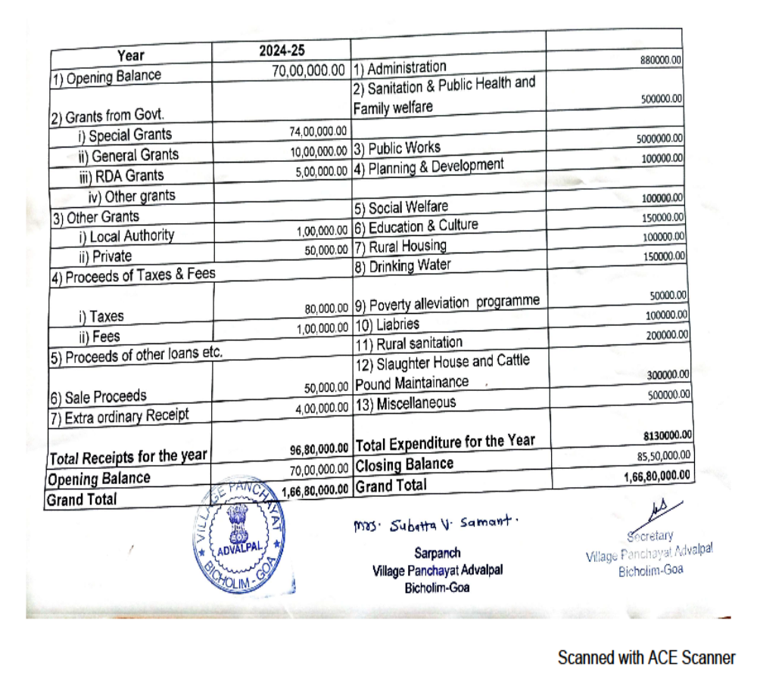
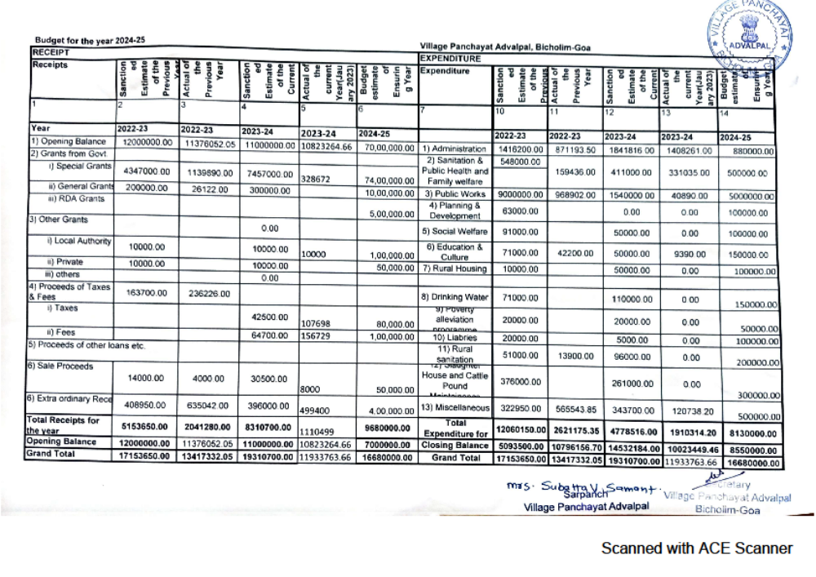

Chapter 12 - Section 4 (1)(b)(xii) of the Right to Information Act, 2005

Manner of execution of subsidy programmes and schemes, including the amounts allocated and the details of beneficiaries of such programmes

The applicants submit their duly filled-in applications along with the enclosures with reference to the various subsidy programmes and schemes routed through the Village Panchayat.
The required enclosures (eg. Gram Sabha Resolution, Income Certificate, Dependency Certificate, etc.) from the Village Panchayat office are handed over to the applicant for submission to the concerned department for availing the necessary benefit. The details of beneficiaries and job card holders are available in the V.P. Office if the concerned department sends them for the general viewing of the public.

Chapter 13 - Section 4 (1)(b)(xiii) of the Right to Information Act, 2005

Particulars of recipients of concessions, permits or authorisations granted by it
Details of concessions, NOC sand Licences issued by Village Panchayat for the financial year
Sr.  No. | Details of Concessions, NOC  or Licenses | Procedure Followed | Number of  Recipients
1 | NOC for Water and Electricity  Connection | As per the Goa Panchayat Raj Act, 1994 | 61
2 | NOC for House Repair and  Construction Licence | As per the Goa Panchayat Raj Act, 1994 | 01 House Repair
3 | Trade License and  Establishment | As per the Goa Panchayat Raj Act, 1994 | 34
4 | License for places for disposal  of Dead Bodies | As per the Goa Panchayat Raj Act, 1994 | ----
6 | Concessions granted | As per the Goa Panchayat Raj Act, 1994 | ----

Chapter 14 - Section 4 (1)(b)(xiv) of the Right to Information Act, 2005

Details in respect of the information available to or held by it, reduced in an electronic form

Details in respect of the information available to or held by it reduced in an electronic form
Sr. No. | Type of Information | Location where available | Format in which Information Available
1 | Documents listed in Chapter 6 | In the Custody of Panchayat Secretary | Hard Copies
2 | Acts, Rules, Amendments, Circulars, OMs | In the Custody of Panchayat Secretary and on Official Website | Hard Copies and in Electronic Form
3 | Details of Schemes available | In the Custody of Panchayat Secretary and on Official Website | Hard Copies and in Electronic Form

Chapter 15 - Section 4 (1)(b)(xv) of the Right to Information Act, 2005

Particulars of facilities available to citizens for obtaining information

Particulars of facilities available to citizens for obtaining information

Sr. No. | Facility/Helpline | Days | Timings
1 | Village Panchayat Official Website | All days of the week | All time
2 | Panchayat Notice Board | All days of the week | All time
3 | Directorate of Panchayat Website | All days of the week | All time
4 | Library (if available) | Monday to Saturday (except public holidays) | 09:00 am to 05:00 pm
5 | Proactive Disclosure | All days of the week | All time on Panchayat Website & Hard copies are available in Panchayat Office on Office hour time
6 | Nirnay Portal / App | All days of the week | All time
7 | E Gram Swaraj Portal | All days of the week | All time
8 | Panchayat Development Portal | All days of the week | All time
9 | GPDP Portal | All days of the week | All time on Panchayat Website

Chapter 16 - Section 4 (1) (b)(xvi) of the Right to Information Act, 2005

Names, designations and other particulars of Authorities under RTI Act, 2005
Details of RTI Authorities
Sr. No. | Name of the Authority | Designation | Positions under the RTI Act | Contact Number | Email Address
1 | Omkar N. Manjrekar | Block Development Officer | First Appellate Authority (FAA) | 9764516365 | bicholimbdo@gmail.com
2 | Sanjay R. Parab | Village Panchayat Secretary | Public Information Officer (PIO) | 9923623423 | vpadvalpal@gmail.com

Chapter 17 - Section 4 (1)(b)(xvii) of The Right to Information Act, 2005

Other Useful Information

Other Useful Information of The Directorate of Panchayats

- Citizen Charter
- Available on the Official Website at https://panchayatsgoa.gov.in

- Grievance Redressal Officer
Name | Sanjay R. Parab
Designation | Village Panchayat Secretary
Address | Village Panchayat Advalpal, Bicholim Goa
Contact | 9923623423
Email | vpadvalpal@gmail.com

- Details of RTI Application and Appeals Received and Disposed in the Year 2024
Total number of RTI Applications received | 11
Total number of RTI Applications disposed | 11
Total number of RTI Applications rejected/not collected | 00
Total number of Appeals made for the Year 2024 | 00

